NZAI Newsletter May 2021

Kia ora : Talofa lava : Mālō e lelei : Kia orana : Talofa ni : Ia orana : Fakaalofa lahi atu : Ni sa bula Vinaka : Halo olaketa : Greetings

It’s such a long time since we sent out an NZAI newsletter. Aotearoa New Zealand was holding its collective breath during 2020 and well into 2021, but now it seems as if we may be able to breathe out, encouraged by the current COVID-19 free situation here in Aotearoa New Zealand and growing vaccine-supported confidence in our ability to sustain it. We’re pleased to let you know about what we’ve been doing in the interim and what’s on the horizon. Some of this will have already been flagged by email, but we’ve taken the opportunity to put all our 2021 news together.

New assessment publication from NZAI
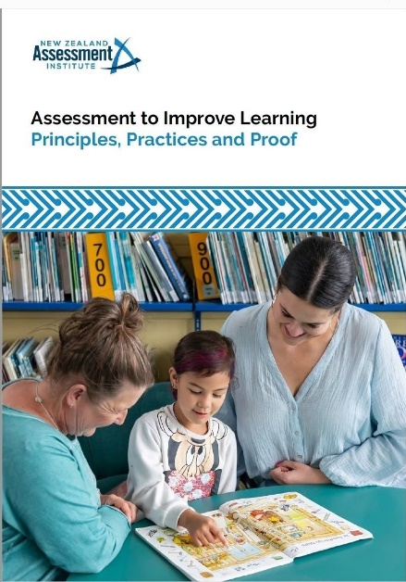
During 2020, NZAI executive members worked on a publication for schools and education agencies to clarify assessment principles and practices. The result is a booklet called Assessment to Improve Learning: Principles, Practices and Proof and an associated Companion Guide.

To coincide with the launch of the publications at the end of March, paper copies were sent to the principals of all schools across the country and to many education agencies. If you would like extra copies, please send a stamped self-addressed envelope to: NZAI, P O Box 99370, Newmarket, Auckland, 1149.

Go to online links to the publications here.

A bank of resources and links to support the Assessment PPP and the Companion Guide is being planned for our website.

We have been pondering the development of our assessment principles and have discovered, in retrospect, that we were guided by an implicit set of ‘metaprinciples’ against which we evaluated them.
You can read about the ‘metaprinciples’ here.

……………………..

Rescheduling our National Conference to October 2021
We are excited to provide news of our National Conference, to be held at Ormiston Junior College on Monday October 4. Save the date!
Conference theme:
Assessment to Improve Learning: Principles, Practices and Proof

The purpose of our day-long conference is to shine a light on the existing assessment practices in schools, support agencies and central agencies to strengthen learning across the system. Presentations will reinforce the content of the assessment resource publication from NZAI published and distributed in March this year under the same name.
NZAI will present a short overview of our thinking on assessment and what we believe would constitute ‘proof of the effect of practices’ – our contribution to ‘building a system that learns’.
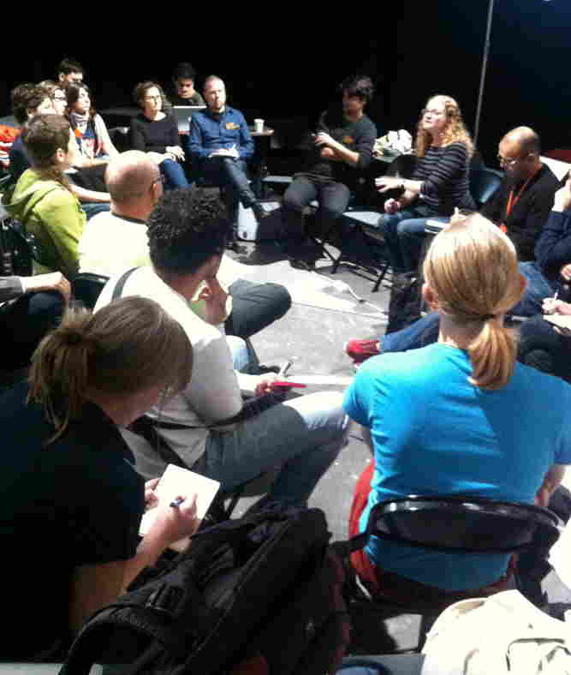
In addition, education agencies will give brief presentations outlining their assessment thinking and practices that support system learning, along with the evidence to date.
The bulk of the day will see four sessions of 10 workshops by teachers, schools and education professionals, highlighting practices and approaches that use assessment as the basis for improving learning. We will of course work to ensure a brilliant line-up of presenters.
We look forward to seeing you at the conference in October. New information including registration details will be available on our website and will be sent to everybody on our mailing list when it becomes available.
……………………..

Assessment Webinars
After the success of the webinars in 2020, NZAI has decided to continue them into 2021. Our first webinar In April was an introduction to the Assessment PPP. You can find a copy of this and all the 2020 webinars here on the NZAI website.
Recent NZAI webinar
Our recent webinar was on Thursday 27th May.
Data coaching to lift teacher capability: a success story
Presenters: Nicola Gibson from Pukekohe Intermediate with Frances Edwards from University of Waikato
They talked about how to initiate data coaching in maths, based on their TLRI project. The focuses were:
(i) the understanding of data literacy and ideas for the coaching process
(ii) the importance of a range of partnerships
(iii) examples of how teachers have collaborated by sharing, analysing, and acting on data.

A copy of the webinar will be posted here on the NZAI website as soon as possible for those unable to attend.
This is the power point used during the webinar.
You can find an article about the work of the presenters here in the Education Gazette.

Next NZAI webinar
Our June webinar is still in the planning but will focus on how to use the Assessment PPP to evaluate your assessment practices. More details will follow.
……………………..

NZAI representation on Curriculum Groups
Our President Jenny Poskitt is representing NZAI on the Curriculum Voices Group in the work to refresh the NZ Curriculum. The introductory hui took place 14-15 April, and the second hui is scheduled for 1 June. You can find the timeline -Refreshing the New Zealand Curriculum for schooling – here on the Ministry of Education website. Among other things, educators will be interested to read that TKI will be ‘progressively replaced with an Online Curriculum Hub’ between 2022 and 2025.

We have been invited to apply for membership of the Curriculum Advisory Group, and will find out soon whether our application is successful.
……………………..

NZAI articles to watch out for


NZARE
The New Zealand Association for Research in Education (NZARE) asked NZAI to submit an article on our new assessment publication for their blog, Ipu Kererū. It should be published within the next few weeks. Keep an eye out here on their website.

The Education Gazette
An article on the same subject, Assessment to Improve Learning: Principles, Practices and Proof, was written for the Education Gazette and is to be published in either the end of May or mid-June editions. Keep an eye out here.

We’ll let you know on our website when and exactly where these articles have been published.
……………………..
Research
Readers may remember from our last newsletter that Beverley Booth, Principal of Devonport Primary School and NZAI Executive member, had completed her doctoral studies in the field of assessment capability. Her thesis is titled: Building the Assessment Capability of New Zealand Teachers. We published a summary of her work in our previous newsletter; her research project investigated how and why assessment capable classroom teachers use particular practices to engender specific skills and aptitudes in their students. We are now pleased to give you the link to her thesis, from the University of Auckland. You can read her thesis here.
……………………..

Online assessment courses available
The Education Hub is offering two online courses in assessment that may be of interest to our members. They are:
August 2021 | Assessment Essentials
10-WEEK COURSE FOR INDIVIDUAL TEACHERS
Assessment Essentials focuses on what teachers need to know about assessment.
and
Assessment Lead Programme
ONE-YEAR COURSE FOR TWO OR MORE LEADERS IN A SCHOOL
The Assessment Lead Programme enables education professionals to make their assessment approach more efficient.

You can find more about these courses here on The Education Hub website.
……………………..

NZAI regional branches and meetings
Regional meetings and the National Seminar have been in abeyance over the past year or so. We are now keen to start them up again. Accordingly, if you would like to join or start a local branch, or consider a regional meeting for the future in your local area, feel free to email at info@nzai.org.nz. We can put you in touch with a local branch if one exists or advise you about getting in touch with a local member of the executive with a view to setting up a local branch. Pre-pandemic local branches include Auckland, Tauranga, New Plymouth and the Wellington area.
……………………..

Your views
As always, we hope you find the newsletter useful and we welcome any feedback that helps us to improve our communication and connection with you.
- What did you find interesting?
- What you would like more of?
- What assessment-related activities are happening in your school or Kāhui Ako that you would be willing to share with other NZAI members?
Email feedback to: info@nzai.org.nz
You can find a list of the NZAI executive members here on our website, representing a wide range of education professionals.
 Follow us on Facebook at @NZAI.org.nz

