NZAI Newsletter June 2023

Kia ora : Talofa lava : Mālō e lelei : Kia orana : Talofa ni : Ia orana : Fakaalofa lahi atu : Ni sa bula Vinaka : Halo olaketa : Greetings

NZAI has loads of assessment news for you. This newsletter covers a well-deserved award, a stimulating new paper on using assessment to revive our education system, a recent article on the value and portability of NCEA, a report from our recent conference with advice on accessing video recordings, information on our next webinar and more.

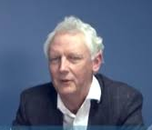
Michael John Absolum ONZM
NZAI Vice-President, Michael Absolum, needs no introduction to many, probably most, of the NZAI whānau. If you haven’t already heard, Michael received a New Zealand Order of Merit (ONZM) in the King’s Birthday Honours List. We’re thrilled for him! How well deserved! You can read the Citation documenting his 40 years of service to the education community here on the DPMC website.

Reviving the Flames of Excellence: Igniting a System that Learns
This is the title of a new paper by Michael Absolum, Adrienne Carlisle and Mary Chamberlain. The subtitle - How Using Assessment Properly Should Solve New Zealand’s Education Woes – explains its purpose.
The paper begins by briefly summarising our current education woes. It then outlines a learning framework that the authors believe will deliver effective learning and system improvement.
The paper then analyses the extent to which the key elements in the framework are present across our compulsory education system, and proposes actions that will ensure that our education system becomes a system that delivers real value for all learners.

You’ll want to read it. You can find it here on our website. Prepare to be challenged!

The value and portability of NCEA
NZAI President Jenny Poskitt wrote this opinion piece for Massey University News in response to media reports about St Cuthbert’s College having discarded NCEA Level 1 in favour of its own in-school assessment.
Jenny’s opinion piece, subsequently published in the New Zealand Herald, highlights the value of NCEA both nationally and internationally, New Zealand’s close connections with international education discourse, and the ways in which NCEA is seeking to integrate subject areas to better equip learners to connect important concepts.
You’ll want to read this too! You can find the article here on the Massey University website.

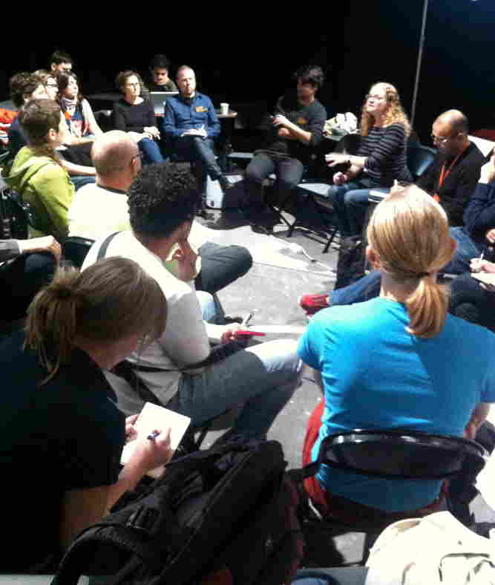
NZAI 2023 Conference – the epilogue
It was exciting for us all to be finally getting together kanohi ki te kanohi at our conference at Ormiston Junior College during the April holidays. This day was followed up by an online conference the following day. A huge thank you to everyone, attendees and presenters, in person and online, for making our conference such a success.
The good news is that all the recorded presentations will be going up on our website at the end of this month, in time for the holidays so that you have some time to dive into them. The link is not yet available but be assured that we’ll send an email to let you know when it is.

NZAI Assessment Webinars
We have a new webinar in the making. Kaye Brunton will be facilitating a discussion on how to use the Companion Guide to the Assessment PPP to further assessment understanding. The guide has helpful suggestions for leaders, teachers, whānau, PLD facilitators and other interested groups.
Date and time: Thursday 27th July, 3.45pm to 4.30pm
Enhancing your assessment capability using questioning and activities
Please register for the webinar through this link. The link will also be here on our website. You will receive an email before the date containing information about joining the webinar. A recording will be posted here on the NZAI website after the session.

Copies of all previous NZAI webinars can be found here on the NZAI website.

NZAI representation on Curriculum and Education Groups
NZAI executive members are well represented in education groups both here in Aotearoa New Zealand and internationally.
Four of seven members of a recently formed MoE Assessment Expert Group are NZAI exec members. They are: Kaye Brunton and Garry Taylor from Evaluation Associates | Te Huinga Kākākura Mātauranga, Associate Professor Jenny Poskitt from Massey University and Esther Smaill from NZCER.
This group will work to update the Ministry of Education Position Paper: Assessment (2011) (you can find it here) to align with the refreshed curriculum.
Additionally, our President Jenny Poskitt is educational advisor on the RNZCGP Academic Tahuhu, chair of NZQA’s Technical Overview Group of Assessment, and research member of the International Education Assessment Network.

Report from recent IEAN meeting in Slovenia
NZAI President Jenny Poskitt has recently returned from the latest IEAN meeting in Slovenia. Attendance at IEAN is by invitation only. IEAN is a network of 12 small nations or states, committed to assessment for learning. Except for the host nation, all countries typically have one researcher and one policy representative. The rationale is that when research and policy collaborate, positive change is more likely to happen.
You can find Jenny’s report on the meeting here on our website.

OECD Education and Skills Newsletter: May 2023
You’ll be interested in finding out what’s being talked about in the OECD education world. You can find their latest newsletter here. Of particular interest is the section titled Innovating Assessments to Measure and Support Complex Skills.

What’s coming up on The Education Hub about assessment?
Professor Gavin Brown of the University of Auckland is chairing a webinar in August called:
In consideration of educational tests: evil, necessary, or beneficial?

In this webinar Professor Gavin Brown (University of Auckland) will take the perspective that, despite unwelcome side effects, schools and teachers need tests to know what students can or cannot do. Find details here on The Education Hub website.

NZAI regional branches and meetings
Regional meetings and the National Seminar have been in abeyance over the long Covid years. We are now keen to start them up again. Accordingly, if you would like to join or start a local branch, or consider a regional meeting for the future in your local area, feel free to email at info@nzai.org.nz. We can put you in touch with a local branch if one exists or advise you about getting in touch with a local member of the executive with a view to setting up a local branch. Pre-pandemic local branches include Auckland, Tauranga, New Plymouth and the Wellington area.

Your views
As always, we hope you find the newsletter useful and we welcome any feedback that helps us to improve our communication and connection with you.
- What did you find interesting?
- What you would like more of?
- What assessment-related activities are happening in your school or Kāhui Ako that you would be willing to share with other NZAI members?
Email feedback to: info@nzai.org.nz
You can find a list of the NZAI executive members here on our website, representing a wide range of education professionals.
 Follow us on Facebook at @NZAI.org.nz

